# Informações do estudo

Referência: Deshpande (treated)

Grandeza: Força

Tipo: Fz

Material: Inconel 718

Ferramenta: TNMG 160408 cryo treated

Número de experimentos: 20

Observações:  
Lathe machine: MTAB CNC  
Dynamometer: Kistler 9257B  
Workpiece: Ø 22 × 120 mm

# Unidades

Velocidade: m/min

Avanço: mm/rev

Profundidade de corte: mm

Força: N

# Dados de teste

|  |  |  |  |
| --- | --- | --- | --- |
| Força | n | f | a |
| 580.0 | 30.0 | 0.18 | 1.07 |
| 160.0 | 110.45 | 0.12 | 0.78 |
| 602.0 | 9.5 | 0.12 | 0.78 |
| 432.0 | 30.0 | 0.05 | 0.5 |

# Dados de treino

|  |  |  |  |
| --- | --- | --- | --- |
| Força | n | f | a |
| 442.0 | 30.0 | 0.05 | 1.07 |
| 555.0 | 60.0 | 0.12 | 0.78 |
| 295.0 | 60.0 | 0.12 | 0.3 |
| 456.0 | 30.0 | 0.18 | 0.5 |
| 225.0 | 60.0 | 0.01 | 0.78 |
| 185.0 | 90.0 | 0.05 | 1.07 |
| 270.0 | 90.0 | 0.18 | 0.5 |
| 461.0 | 60.0 | 0.12 | 0.78 |
| 440.0 | 60.0 | 0.22 | 0.78 |
| 390.0 | 60.0 | 0.12 | 1.26 |
| 551.0 | 60.0 | 0.12 | 0.78 |
| 445.0 | 60.0 | 0.12 | 0.78 |
| 190.0 | 90.0 | 0.18 | 1.07 |
| 147.0 | 90.0 | 0.05 | 0.5 |
| 476.0 | 60.0 | 0.12 | 0.78 |
| 445.0 | 60.0 | 0.12 | 0.78 |

# RN

Número de neurônios: 83

Taxa de aprendizado: 1.000000e-02

Número de épocas: 337

2° camada: True

Função de ativação: relu

# Erros

**Dados de teste**

* Erro relativo médio: 16.5
* Coeficiente de correlação: 0.99
* Coeficiente de determinação: 0.98
* MSE: 3894.78
* RMSE: 62.41

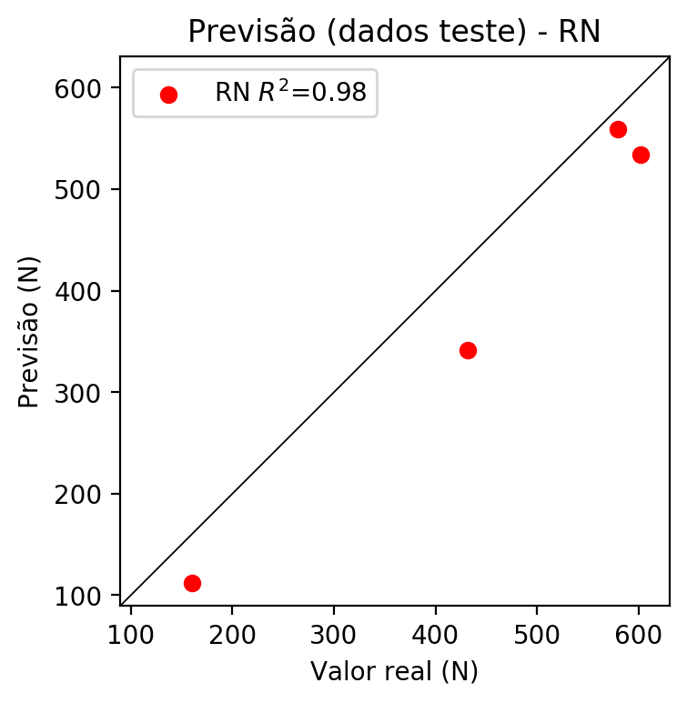

**Dados de treino**

* Erro relativo médio: 3.23
* Coeficiente de correlação: 0.98
* Coeficiente de determinação: 0.95
* MSE: 814.05
* RMSE: 28.53

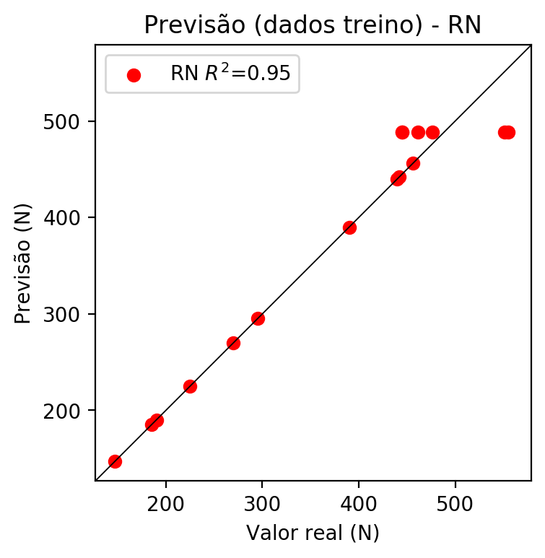

# Pesos

Pesos - camada oculta 1

[[ 9.55634192e-02 3.88056599e-02 -2.03027591e-01 -8.67859423e-02  
 1.90980658e-01 -2.88198665e-02 7.73612857e-02 6.29786104e-02  
 -6.39168248e-02 1.57224789e-01 -2.70546883e-01 1.11324355e-01  
 4.30203155e-02 -5.38533963e-02 -1.35750145e-01 -3.56327444e-02  
 1.31613389e-01 -9.05591547e-02 -6.74155131e-02 2.81143427e-01  
 2.02972472e-01 2.35132366e-01 1.44664375e-02 6.78403899e-02  
 -5.97950304e-03 -1.90208122e-01 3.11679095e-01 1.10702500e-01  
 1.45493373e-01 -2.05324739e-01 3.14111486e-02 -2.58075565e-01  
 -5.68550713e-02 -7.39485621e-02 1.10958084e-01 -1.55558676e-01  
 3.91120277e-02 1.73258066e-01 -1.22735471e-01 -1.02372572e-01  
 1.71995714e-01 2.12602988e-01 1.84262291e-01 1.98330030e-01  
 3.79632004e-02 1.62064582e-02 -3.96035686e-02 -2.03916237e-01  
 2.57103503e-01 2.93658465e-01 1.90083817e-01 8.55991244e-02  
 1.33663759e-01 -5.49962707e-02 -2.38301400e-02 -2.32086647e-02  
 1.24105953e-01 5.11987731e-02 -1.20856866e-01 -2.12613568e-01  
 1.72820538e-01 -1.54866442e-01 -1.20301209e-01 1.19382329e-01  
 3.04615706e-01 -2.30406582e-01 1.68811753e-02 7.29763582e-02  
 -1.03351213e-01 -1.45348264e-02 -3.25501971e-02 -4.07868857e-03  
 4.82375845e-02 -6.44247308e-02 1.80835992e-01 -1.97324961e-01  
 5.71782421e-03 1.24802068e-01 -4.80562374e-02 1.83364972e-02  
 2.07915038e-01 -1.72756478e-01 -2.42449611e-01]  
 [ 1.42273773e-02 -1.27151385e-01 2.69282460e-01 -6.28249301e-03  
 -2.52903968e-01 -2.32706711e-01 7.22460449e-02 -2.77549704e-03  
 -1.44151971e-01 -3.27343136e-01 9.38698128e-02 -1.49216771e-01  
 -1.39704138e-01 -1.28652722e-01 1.05525963e-01 1.58435613e-01  
 -1.69139370e-01 4.31272620e-03 -4.42044623e-02 2.69398838e-01  
 -1.32646367e-01 -2.86381990e-01 -2.49473333e-01 -4.70517166e-02  
 -9.83684137e-02 9.97819304e-02 1.49287179e-01 -2.39358917e-02  
 -5.14165349e-02 2.24428579e-01 2.30097488e-01 3.92648615e-02  
 2.38541082e-01 7.33462200e-02 -1.47828352e-04 -1.38245046e-01  
 -5.44468164e-02 7.71177635e-02 -1.98741972e-01 8.65093432e-03  
 -1.72115162e-01 2.63673663e-01 -3.72429118e-02 2.19574362e-01  
 -1.96531252e-03 -2.85078138e-01 -1.19458266e-01 8.46830681e-02  
 2.43801102e-02 -4.90269884e-02 9.39603820e-02 1.43223420e-01  
 2.04464644e-01 -1.33998871e-01 1.01375900e-01 -1.34480342e-01  
 1.39568776e-01 -1.02432482e-02 -2.35860988e-01 2.72706505e-02  
 5.16784191e-02 4.96398937e-03 -7.11619407e-02 1.85341045e-01  
 1.82773843e-01 1.66554928e-01 7.30662432e-04 2.16152668e-01  
 -7.54402429e-02 8.91320705e-02 -2.51029223e-01 -1.03921250e-01  
 -2.46709287e-01 4.84372750e-02 2.25048050e-01 1.40731335e-01  
 2.63978168e-02 -8.55063722e-02 8.30225423e-02 -2.43094072e-01  
 -5.16020209e-02 -1.97334960e-01 -1.79045454e-01]  
 [ 1.79149717e-01 -1.59783527e-01 -1.62812829e-01 -8.08202326e-02  
 -1.18642345e-01 1.95291325e-01 -1.75087601e-01 1.11458451e-01  
 -3.30313265e-01 6.19041994e-02 -1.35395378e-01 1.16206452e-01  
 5.44010252e-02 -2.51928508e-01 2.09937364e-01 1.48237616e-01  
 1.68868601e-01 5.56101613e-02 -1.50488198e-01 -4.15234938e-02  
 2.89885461e-01 1.94111973e-01 5.27519220e-03 -1.26507506e-01  
 -9.70586091e-02 -1.08467072e-01 -7.31712282e-02 2.10743565e-02  
 3.66796739e-02 3.50402519e-02 1.72419056e-01 1.44646227e-01  
 1.05657587e-02 -3.90669443e-02 1.53981715e-01 -2.85926402e-01  
 1.41935304e-01 1.11534223e-01 -1.55844003e-01 -9.90308821e-03  
 -1.03813909e-01 2.28843279e-02 -4.79933210e-02 1.78947985e-01  
 1.26096040e-01 -1.26060396e-01 -1.22130468e-01 1.04080074e-01  
 1.66599751e-01 1.93377435e-02 1.82491764e-01 6.70245811e-02  
 1.60160899e-01 1.01406932e-01 1.72105104e-01 2.12611184e-01  
 2.77440082e-02 1.39489621e-01 1.46040469e-01 -1.52237535e-01  
 6.40691146e-02 -1.90069780e-01 4.35040370e-02 -2.66669542e-01  
 -1.46484688e-01 -3.27426866e-02 4.26062793e-02 -1.88103721e-01  
 1.83927909e-01 -3.48400399e-02 -1.04994088e-01 -9.83734056e-02  
 2.20608205e-01 -3.20675373e-02 8.87058005e-02 1.00918477e-02  
 7.62041509e-02 -9.88146737e-02 9.81339812e-02 1.06615841e-01  
 -2.91661005e-02 -1.38679251e-01 7.08076656e-02]]

Bias - camada oculta

[-0.06501096 -0.05143608 0.1260376 0.06339546 -0.07243043 -0.10364236  
 -0.08599208 -0.05901336 -0.0216472 -0.02638114 0.11651803 -0.02758168  
 -0.05539016 -0.08704884 -0.08950679 0.12986451 -0.05386399 0.13798061  
 -0.10939297 0.06860404 -0.04000554 0.03536617 -0.08610996 -0.02422408  
 -0.07565679 -0.05188771 -0.05329203 -0.00483306 -0.08923606 0.1110008  
 -0.04156188 0.14991271 0.12049131 -0.1000534 -0.07672809 -0.04764091  
 0.05136752 -0.06654447 -0.08759081 -0.12717126 -0.0150775 -0.05037329  
 0.0438638 -0.03845544 -0.04773908 -0.04349707 -0.11546244 0.13348526  
 -0.06465741 -0.06060297 -0.03549672 -0.07805742 -0.06412954 0.09069037  
 -0.06422096 0.14850146 -0.06605689 0.13542037 0.1387094 0.14369129  
 -0.02476658 -0.08128299 -0.09733056 -0.04781706 -0.05599462 0.09369846  
 -0.11586962 -0.06729531 -0.06984899 -0.10827021 -0.03650445 -0.06246812  
 -0.07150251 -0.08231682 -0.04110567 0.1171787 -0.07266607 -0.07916285  
 -0.09275395 -0.07404952 -0.05342966 -0.06949031 0.14174199]

Pesos - camada oculta 2

[[ 0.04120197 -0.03036705 -0.0755299 ... 0.07806554 -0.13789362  
 -0.12424226]  
 [-0.03743245 -0.17993896 0.2043868 ... -0.09191111 -0.08340108  
 -0.13254221]  
 [ 0.09714339 -0.06791424 -0.20142701 ... 0.01630248 0.09087577  
 -0.0617867 ]  
 ...  
 [-0.03862915 0.00282507 0.22943413 ... -0.02110555 -0.04175468  
 0.2349447 ]  
 [-0.28065035 -0.07866536 0.09008995 ... 0.07657767 0.14419828  
 -0.08775887]  
 [ 0.03248954 -0.00741638 -0.04317943 ... 0.08816165 0.11900151  
 -0.20465185]]

Bias - camada oculta 2

[-0.09123179 -0.06479744 -0.06976324 -0.08999386 -0.09009705 -0.06717713  
 -0.05712957 -0.15990758 -0.04087328 -0.07415073 -0.05584226 0.14446911  
 -0.0636066 -0.06177615 -0.05999819 -0.01130241 -0.06822508 -0.07351104  
 -0.04873588 0.14181595 0.14616567 -0.05377739 -0.06750066 -0.06228271  
 -0.05924056 -0.0735766 -0.08916295 -0.04686007 0.1397886 -0.01048984  
 -0.06664157 -0.04463363 -0.04372472 -0.03374619 -0.07357053 -0.06982861  
 -0.06167264 -0.06004928 0. -0.06911018 0.15649591 -0.07331083  
 -0.10603553 0.14923847 0.04657856 -0.04399048 -0.06935253 -0.02443591  
 0.0932837 0.16137475 0.1421085 -0.07965799 0.10732327 -0.05116202  
 -0.07619732 -0.06747568 0.09304494 0.16857414 -0.02500729 -0.05219702  
 -0.04721202 -0.07638756 -0.06814455 0.14916795 0.12895264 -0.07448114  
 -0.06558365 0.09693645 -0.06806093 -0.06261221 -0.05984993 0.14434953  
 -0.05641305 0. 0.11790139 -0.03106982 0.08400704 0.16777007  
 0.14625067 -0.09471974 0.14714018 -0.06649224 -0.04831192]

Pesos - camada saída

[[ 0.10066546 -0.01220744 -0.15958421 -0.03908427 0.0846737 -0.11204966  
 -0.06671341 -0.05402185 -0.11949694 -0.00898944 -0.2655253 0.12554666  
 0.02865031 -0.06106452 -0.0598863 -0.05113033 -0.01044784 -0.03254849  
 -0.23620677 0.23518282 0.2292262 0.11970205 -0.06989411 0.04597124  
 -0.06503141 -0.118256 0.19225292 -0.02593054 0.14838193 -0.1937596  
 -0.02453921 -0.2619433 -0.18886119 -0.15260267 -0.02078471 -0.17403449  
 -0.00592955 0.06386931 -0.1989541 -0.09244416 0.13672797 0.06325012  
 0.14065671 0.20410278 0.01252288 -0.00861991 0.00247 -0.11174654  
 0.2116923 0.23474772 0.13178185 0.10462808 0.06657376 -0.04888888  
 -0.00631779 -0.0171139 0.00750655 0.00260287 -0.2694449 -0.23348974  
 0.13036452 -0.16572459 -0.24817702 0.09692281 0.17330837 -0.23672968  
 -0.04663257 0.02100461 -0.14775847 -0.11481299 -0.09303997 0.01948513  
 -0.00588555 -0.19389391 0.05194908 -0.08222279 0.00934143 0.23303708  
 -0.00084174 -0.01722863 0.15773502 -0.2576569 -0.26207164]]

# Iterações

|  |  |  |  |  |  |  |
| --- | --- | --- | --- | --- | --- | --- |
| Média | Desvio | n | ln | 2° camada | Função | Épocas |
| -0.3348 | 0.3091 | 10 | 0.1 | False | relu | 38 |
| -0.5023 | 0.3389 | 17 | 0.1 | True | relu | 716 |
| -0.2618 | 0.1684 | 7 | 0.01 | True | tanh | 130 |
| -1.1861 | 0.8053 | 19 | 0.001 | False | tanh | 282 |
| -0.9302 | 0.6587 | 29 | 0.001 | False | relu | 469 |
| -0.6315 | 0.4264 | 88 | 0.1 | False | tanh | 926 |
| -0.2591 | 0.1025 | 95 | 0.0001 | True | relu | 984 |
| -0.4556 | 0.3627 | 10 | 0.01 | True | tanh | 865 |
| -0.7518 | 0.3577 | 58 | 0.001 | True | relu | 8 |
| -0.4664 | 0.373 | 9 | 0.01 | False | tanh | 514 |
| -0.3587 | 0.2796 | 73 | 0.0001 | True | relu | 729 |
| -0.5897 | 0.2903 | 22 | 0.001 | True | relu | 543 |
| -0.4318 | 0.2415 | 25 | 0.1 | True | relu | 562 |
| -0.8728 | 0.7934 | 53 | 0.001 | False | relu | 498 |
| -0.2384 | 0.1797 | 83 | 0.01 | True | relu | 337 |
| -1.1743 | 0.6533 | 99 | 0.01 | False | tanh | 16 |
| -0.6369 | 0.4171 | 23 | 0.01 | False | relu | 472 |
| -0.3052 | 0.114 | 24 | 0.001 | True | relu | 778 |
| -0.4601 | 0.2994 | 58 | 0.01 | True | tanh | 382 |
| -0.5116 | 0.3832 | 35 | 0.1 | False | tanh | 596 |

# RL

# Coeficientes

[ 0. -0.85718923 0.26393715 0.09724847]

# Erros

**Dados de teste**

* Erro relativo médio: 7.96
* Coeficiente de correlação: 1.0
* Coeficiente de determinação: 0.99
* MSE: 1097.24
* RMSE: 33.12

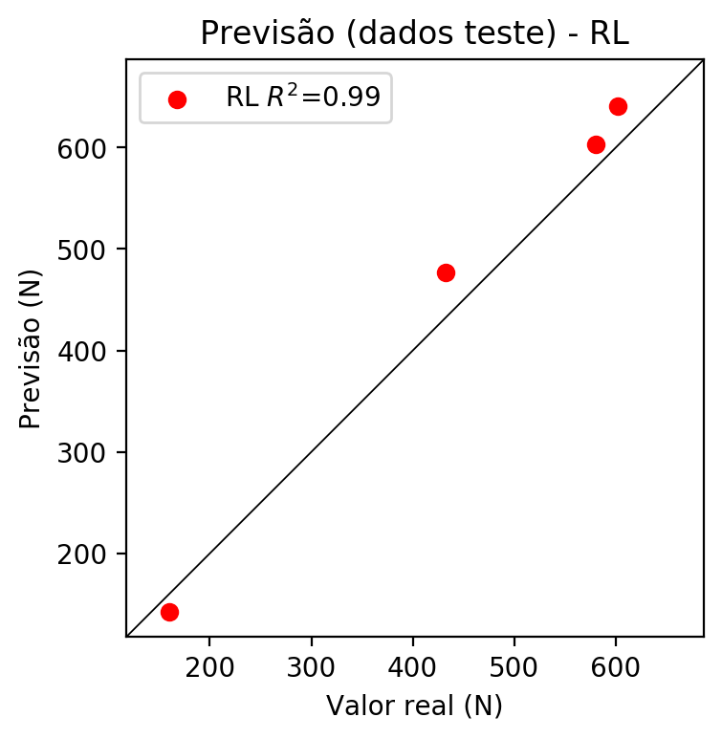

**Dados de treino**

* Erro relativo médio: 20.92
* Coeficiente de correlação: 0.75
* Coeficiente de determinação: 0.56
* MSE: 7350.9
* RMSE: 85.74

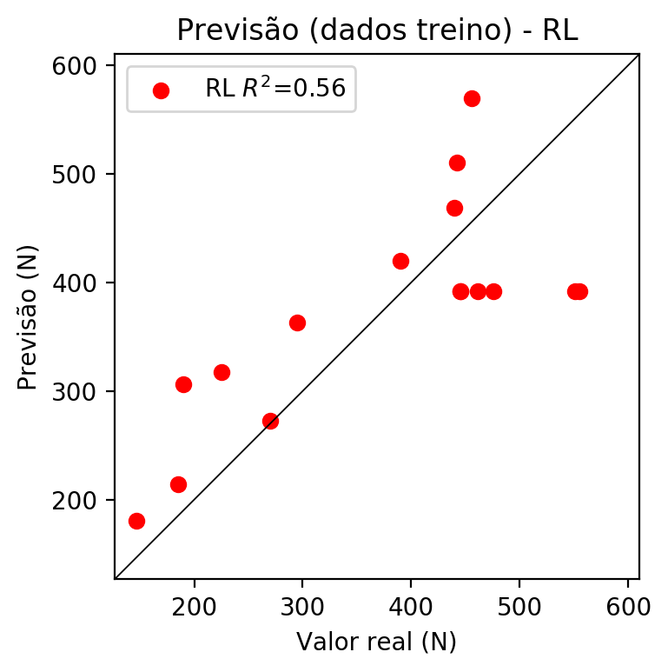

# RP2

# Coeficientes

[ 0. -0.64087865 0.36500689 0.1887081 -0.34374364 -0.13968944  
 -0.22797518 -0.28062066 -0.14338439 -0.25319352]

# Erros

**Dados de teste**

* Erro relativo médio: 27.08
* Coeficiente de correlação: 0.92
* Coeficiente de determinação: 0.84
* MSE: 16238.78
* RMSE: 127.43

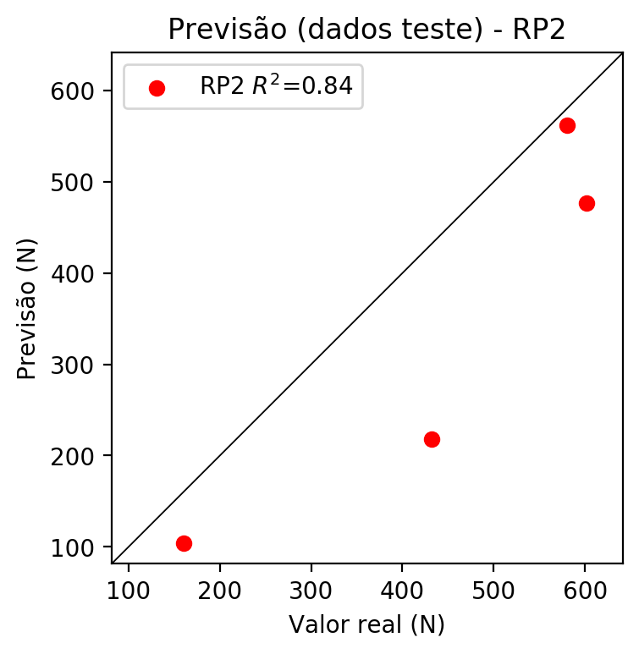

**Dados de treino**

* Erro relativo médio: 4.41
* Coeficiente de correlação: 0.97
* Coeficiente de determinação: 0.95
* MSE: 840.54
* RMSE: 28.99

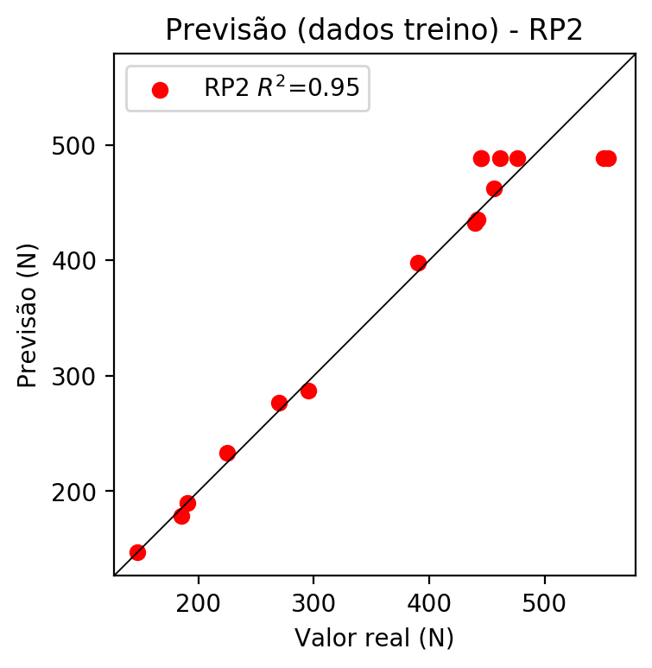

# RP3

# Coeficientes

[ 5.55111512e-17 -1.14949606e-01 2.26132940e-02 1.24249799e-03  
 -2.08605983e-01 3.20159868e-02 -5.38829301e-02 -2.87593318e-01  
 -1.72716404e-02 -2.53280590e-01 -1.59928595e-01 -6.22371395e-03  
 -1.97092780e-02 -1.62990110e-01 -1.07051029e-01 -1.59917683e-01  
 9.65415673e-02 -1.99404219e-02 -6.07366661e-03 4.09025214e-02]

# Erros

**Dados de teste**

* Erro relativo médio: 6.22
* Coeficiente de correlação: 0.98
* Coeficiente de determinação: 0.97
* MSE: 1140.88
* RMSE: 33.78

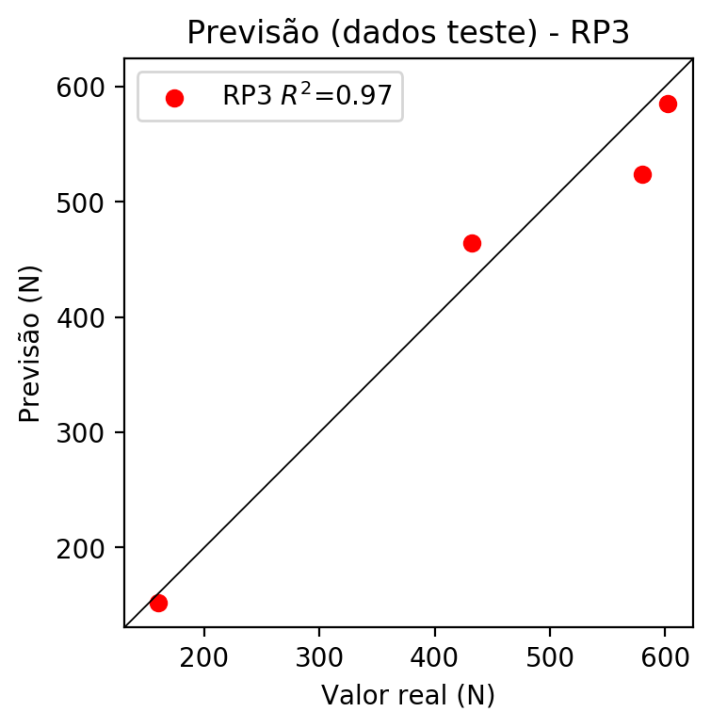

**Dados de treino**

* Erro relativo médio: 3.23
* Coeficiente de correlação: 0.98
* Coeficiente de determinação: 0.95
* MSE: 814.05
* RMSE: 28.53

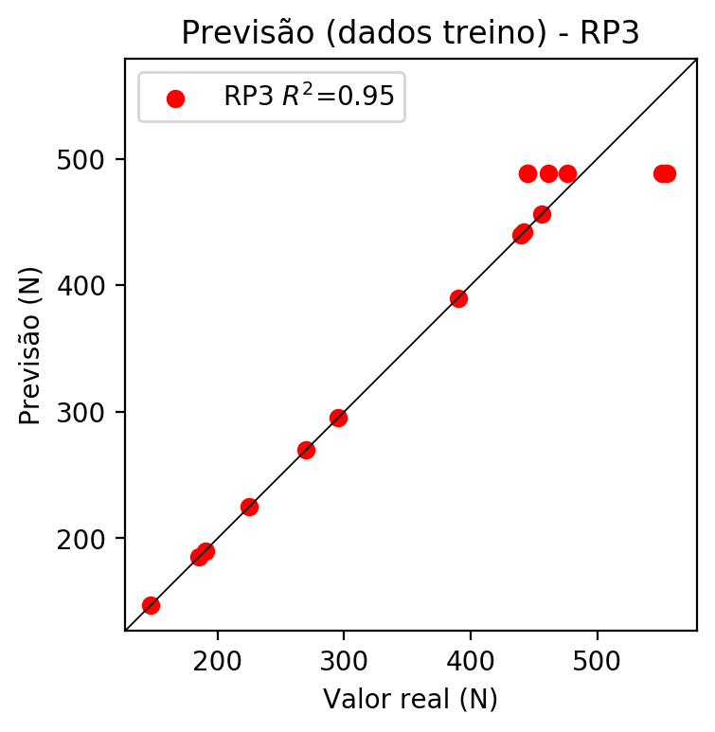

# RP4

# Coeficientes

[-1.38777878e-17 -9.00690848e-02 2.54970877e-02 4.77672098e-03  
 -7.03952966e-02 1.31661891e-03 -1.09546139e-02 -6.22166834e-02  
 -2.34882441e-02 -5.80631220e-02 -1.25285061e-01 -3.31998035e-05  
 -1.14749375e-02 -1.27521279e-01 1.49974553e-02 -1.25277212e-01  
 9.96692047e-02 -1.15042634e-02 -8.82605441e-05 3.96947035e-02  
 -9.79274539e-02 1.82760372e-03 -1.52392537e-02 -9.96542677e-02  
 -3.26045925e-02 -9.79096594e-02 2.80376494e-03 -1.56194295e-02  
 1.83385057e-03 -1.52841306e-02 -5.87559757e-02 -3.30861878e-02  
 -9.96359180e-02 -3.27956815e-02 -4.95830950e-02]

# Erros

**Dados de teste**

* Erro relativo médio: 37.56
* Coeficiente de correlação: 0.98
* Coeficiente de determinação: 0.97
* MSE: 22255.88
* RMSE: 149.18

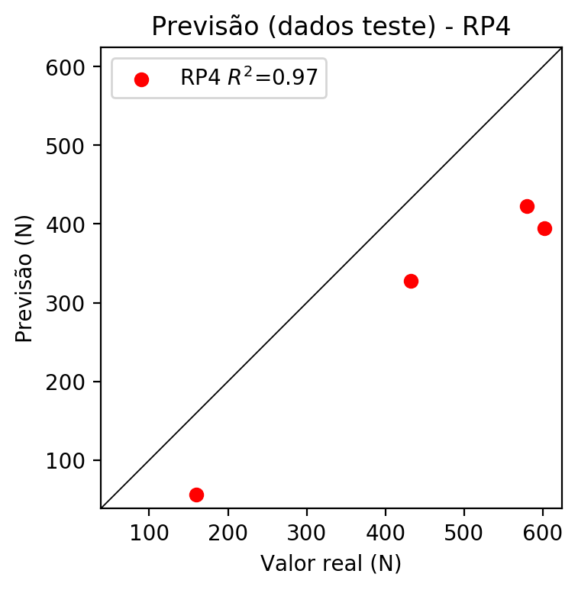

**Dados de treino**

* Erro relativo médio: 3.23
* Coeficiente de correlação: 0.98
* Coeficiente de determinação: 0.95
* MSE: 814.05
* RMSE: 28.53

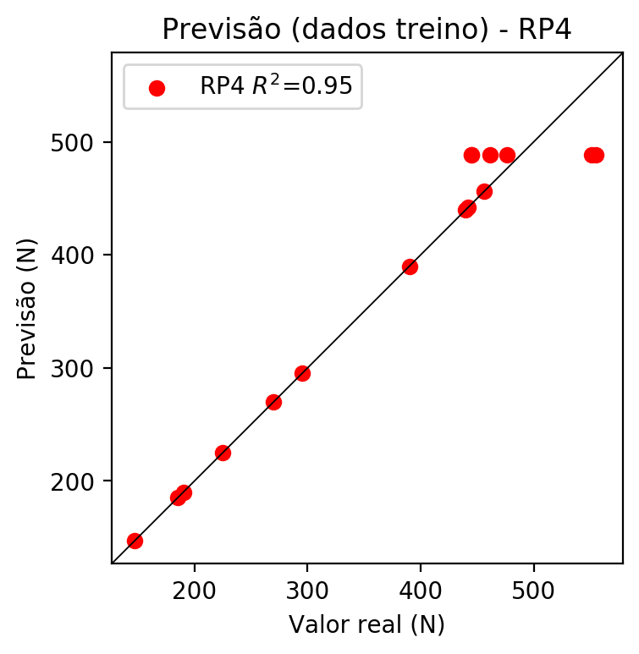

# Geral

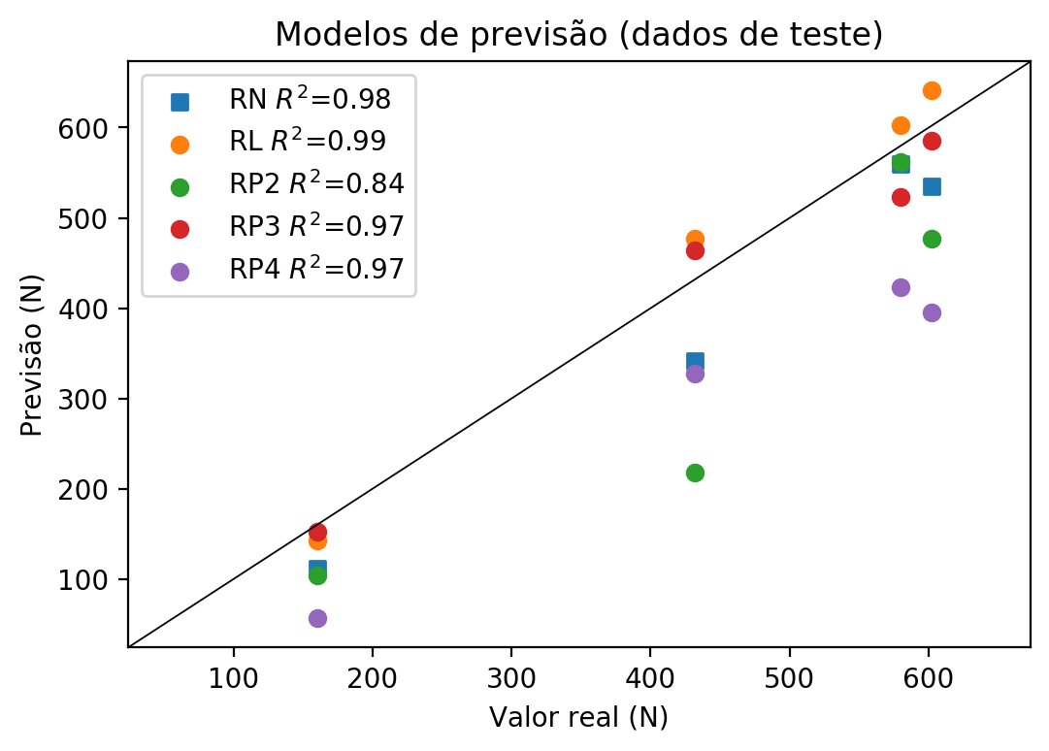

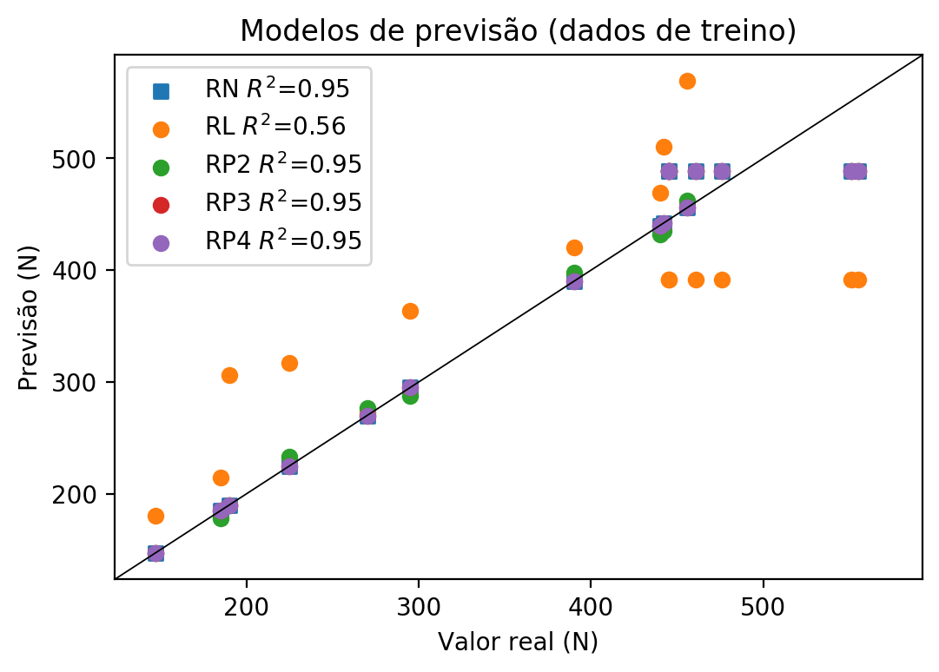

**Dados de teste**

|  |  |  |  |  |  |  |  |  |  |  |
| --- | --- | --- | --- | --- | --- | --- | --- | --- | --- | --- |
| Valor real | RN Previsto | RN Erro (%) | RL Previsto | RL Erro (%) | RP2 Previsto | RP2 Erro (%) | RP3 Previsto | RP3 Erro (%) | RP4 Previsto | RP4 Erro (%) |
| 580.0 | 559.49 | 3.54 | 602.75 | 3.92 | 561.96 | 3.11 | 523.58 | 9.73 | 423.03 | 27.06 |
| 160.0 | 111.68 | 30.2 | 142.41 | 10.99 | 104.25 | 34.84 | 152.13 | 4.92 | 56.56 | 64.65 |
| 602.0 | 534.52 | 11.21 | 641.17 | 6.51 | 476.53 | 20.84 | 585.24 | 2.78 | 395.13 | 34.36 |
| 432.0 | 341.06 | 21.05 | 477.03 | 10.42 | 218.04 | 49.53 | 464.21 | 7.46 | 327.65 | 24.16 |

**Dados de treino**

|  |  |  |  |  |  |  |  |  |  |  |
| --- | --- | --- | --- | --- | --- | --- | --- | --- | --- | --- |
| Valor real | RN Previsto | RN Erro (%) | RL Previsto | RL Erro (%) | RP2 Previsto | RP2 Erro (%) | RP3 Previsto | RP3 Erro (%) | RP4 Previsto | RP4 Erro (%) |
| 442.0 | 442.0 | 0.0 | 510.66 | 15.53 | 435.42 | 1.49 | 442.0 | 0.0 | 442.0 | 0.0 |
| 555.0 | 488.83 | 11.92 | 391.67 | 29.43 | 488.73 | 11.94 | 488.83 | 11.92 | 488.83 | 11.92 |
| 295.0 | 295.0 | 0.0 | 363.35 | 23.17 | 287.2 | 2.64 | 295.0 | 0.0 | 295.0 | 0.0 |
| 456.0 | 456.0 | 0.0 | 569.12 | 24.81 | 462.58 | 1.44 | 456.0 | 0.0 | 456.0 | 0.0 |
| 225.0 | 225.0 | 0.0 | 317.29 | 41.02 | 233.3 | 3.69 | 225.0 | 0.0 | 225.0 | 0.0 |
| 185.0 | 185.0 | 0.0 | 214.21 | 15.79 | 178.42 | 3.56 | 185.0 | 0.0 | 185.0 | 0.0 |
| 270.0 | 270.0 | 0.0 | 272.67 | 0.99 | 276.58 | 2.44 | 270.0 | 0.0 | 270.0 | 0.0 |
| 461.0 | 488.83 | 6.04 | 391.67 | 15.04 | 488.73 | 6.02 | 488.83 | 6.04 | 488.83 | 6.04 |
| 440.0 | 440.0 | 0.0 | 468.88 | 6.56 | 432.3 | 1.75 | 440.0 | 0.0 | 440.0 | 0.0 |
| 390.0 | 390.0 | 0.0 | 419.93 | 7.67 | 397.84 | 2.01 | 390.0 | 0.0 | 390.0 | 0.0 |
| 551.0 | 488.83 | 11.28 | 391.67 | 28.92 | 488.73 | 11.3 | 488.83 | 11.28 | 488.83 | 11.28 |
| 445.0 | 488.83 | 9.85 | 391.67 | 11.98 | 488.73 | 9.83 | 488.83 | 9.85 | 488.83 | 9.85 |
| 190.0 | 190.0 | 0.0 | 306.31 | 61.22 | 190.0 | 0.0 | 190.0 | 0.0 | 190.0 | 0.0 |
| 147.0 | 147.0 | 0.0 | 180.58 | 22.84 | 147.0 | 0.0 | 147.0 | 0.0 | 147.0 | 0.0 |
| 476.0 | 488.83 | 2.7 | 391.67 | 17.72 | 488.73 | 2.67 | 488.83 | 2.7 | 488.83 | 2.7 |
| 445.0 | 488.83 | 9.85 | 391.67 | 11.98 | 488.73 | 9.83 | 488.83 | 9.85 | 488.83 | 9.85 |